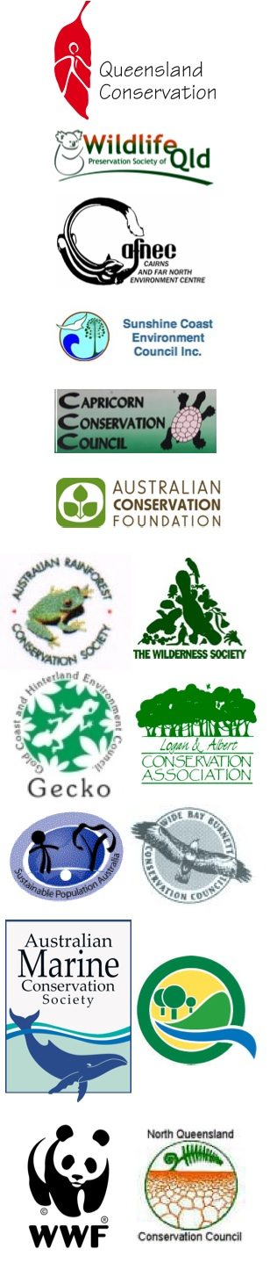

Media Alert

Launch of Queensland Environment Groups Election Scorecard

Where do the major parties stand on the key environment issues at this State election?

Place: Queensland Conservation Office
166 Ann St
Brisbane

Date: Tuesday 17th March 2009

Time: 1.00 pm

For Further Information:

Toby Hutcheon (QCC) 3221 0188/0419664 503
Don Henry (ACF) 0418 501395
Tim Seelig (TWS) 0439 201183
Nick Heath (WWF) 0418 885324
Simon Baltais (SPA) 0412 075 334

