30th March 2009

The Honourable Ms Anna Bligh, MP
Premier and Minister for the Arts
PO Box 15185
City East Brisbane 4002

cc: The Honourable Stirling Hinchliffe, Minister for Infrastructure and Planning
The Honourable Kate Jones, Minister for Climate Change and Sustainability

Dear Premier and Ministers

Re: Draft SEQ Regional Plan 2009-2031 – request for rewrite

Due to the interruption of the consultation with regard to the Draft SEQ Regional Plan 2009-2031 and the policies upon which it is based during the election period, Gecko and its member groups request that the consultation on this draft be postponed until:

- The policies and procedures upon which the Plan is based have had full community consultation and adoption (see attached submission to Draft Policy on Biodiversity Offsets);
- The provisions in the draft have been rewritten in keeping with the latest science of climate change and knowledge about the biodiversity significance of South East Queensland;
- The draft has been fully analysed in comparison with the State of the Region Report for its potential impacts on sustainability indicators;
- The community has had the opportunity to examine several options for the future as is best practice for community consultation on regional planning.

As shown in the Redland City Council submission, many of the policies, priorities and programs are poorly written and need to be strengthened in order to achieve any of the Desired Regional Outcomes. We also fear that the impact of new provisions in the Plan on our biodiversity and natural areas has not been adequately considered.

We are also concerned that if the consultation period is extended, the analysis of the submissions and issues and the preparation of the final updated plan should not be accelerated, but that the date of release of the Plan be postponed until these phases of preparation are thoroughly addressed.

As this Draft Plan will have a major impact on the communities and environment of our region, we request an extension and delay of the implementation of the Plan until these issues have been resolved.

Yours faithfully
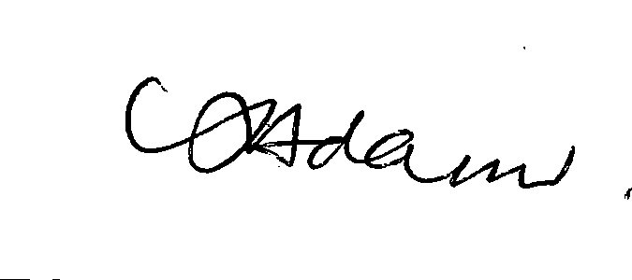
Rose Adams, Gecko President

