For immediate release 20 October 2010
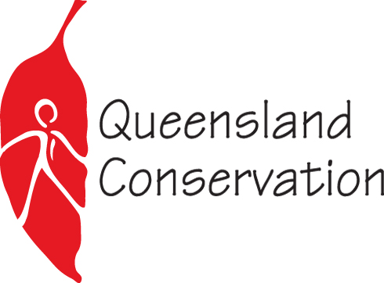
Media Release
Waterways holding steady, but problems looming ahead
While this year’s report card shows that most South East Queensland waterways are holding steady, SEQ environment groups warn of the looming threat to Moreton Bay from the sheer scale of proposed urban development throughout the region.

“While we acknowledge the great work done by the Healthy Waterways Partnership to improve Moreton Bay’s health, over a decades worth of achievements could be undone if the massive new unsustainable urban development throughout SEQ is allowed to occur with out having to fully consider and put in place measures to avoid impacts to waterways.” said Simon Baltais of QCC and Wildlife Queensland

“The time for experiments and small scale projects is over. What we urgently need instead are large-scale catchment wide rehabilitation projects and the adoption of world’s best development standards. SEQ environment groups believe in the vicinity of one billion dollars needs to be invested to repair catchment degradation throughout the region; otherwise the ecological health of Moreton Bay is likely to continue to decline overtime.”

“This years results clearly show the internationally significant Pumicestone Passage is being heavily impacted from existing development pressures, yet the State Government is fast-tracking the massive Caloundra South development. Unless done with stringent environmental controls that consider catchment-wide cumulative impacts, building a city the size of Gladstone on the foreshore of Pumicestone Passage will cause huge impacts to Moreton Bay.” said Narelle McCarthy, Sunshine Coast Environment Council Campaigns Manager

‘’The 2010 report card shows the condition of the Albert and Logan estuaries remain in poor condition, despite over ten years of hard work to improve their ecological health. The poor estuary health is caused by high nutrient and sediment levels, which is continued to be caused by existing inappropriate urban and industrial development throughout the catchment. Impacts to waterways are set to escalate if a business as usual approach is taken to the massive urban development planned for our part of the region.” said Andy Grodecki from the Logan and Albert Conservation Association.
………………………………………………………..END………………………………………………………………
Media enquiries:
Narelle McCarthy: 0424 465 487 (Sunshine Coast Environment Council)
Andy Grodecki: 0407 389 (Logan and Albert Conservation Association)
Simon Baltais: 0447 539 968 (Queensland Conservation Council)

